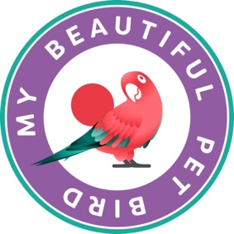

**FOR IMMEDIATE RELEASE** **Contact: Cindy Woudenberg**

**Tel: 602-363-5054**

[**cindy@lucorpmarketing.com**](mailto:cindy@lucorpmarketing.com)

**Bird Enjoyment & Advantage Koalition (BEAK) Announces Annual Contest Celebrating National Pet Bird Day**

***The “My Beautiful Pet Bird” contest invites bird owners to submit photos or videos of their pets for a chance to win up to $500.***

In preparation for the 7th Annual National Pet Bird Day, taking place on September 17, 2025, the Bird Enjoyment & Advantage Koalition (BEAK) and its consumer-facing campaign, MyBird, are excited to announce the “My Beautiful Pet Bird” contest. This contest invites bird owners across the U.S. to submit original photos or short videos that showcase their pets’ unique beauty by August 20; the general public will have a chance to vote for their favorite entry until September 13, and a committee of judges will then select three winners from the top ten entries as determined by popular vote. Winners will be announced on September 17, with first place receiving a $500 cash prize, second place receiving $250 and third place receiving $100.

Formed in 2016, BEAK consists of bird product manufacturers, retailers and associations united to address the need for responsible bird ownership and growth. The group established MyBird as a way to engage current and potential bird owners, encourage interest in pet bird ownership and provide education on responsible bird care.

While MyBird draws plenty of engagement from bird lovers throughout the year – including 500,000 annual page views at <https://myrightbird.com> and over 230,000 Facebook followers – the weeks leading up to National Pet Bird Day are among the most active for the pet bird community. In honor of the special day, which was established by BEAK in 2019 as a way to celebrate the joys and benefits of owning a pet bird, many of BEAK’s member businesses run special promotions. Bird lovers are also encouraged to access the National Pet Bird Day toolkit at <https://myrightbird.com/national-pet-bird-day>, which includes several free, downloadable graphics and social media posts, and join in the festivities by sharing stories, photos and videos of their birds on social media using the hashtag #NationalPetBirdDay.

BEAK and MyBird are excited to review contest submissions and join the rest of the pet bird community in celebrating the 7th Annual National Pet Bird Day. To learn more about the “My Beautiful Pet Bird” contest or to submit a photo or video entry, visit <https://myrightbird.com/my-beautiful-pet-bird-contest>.

###