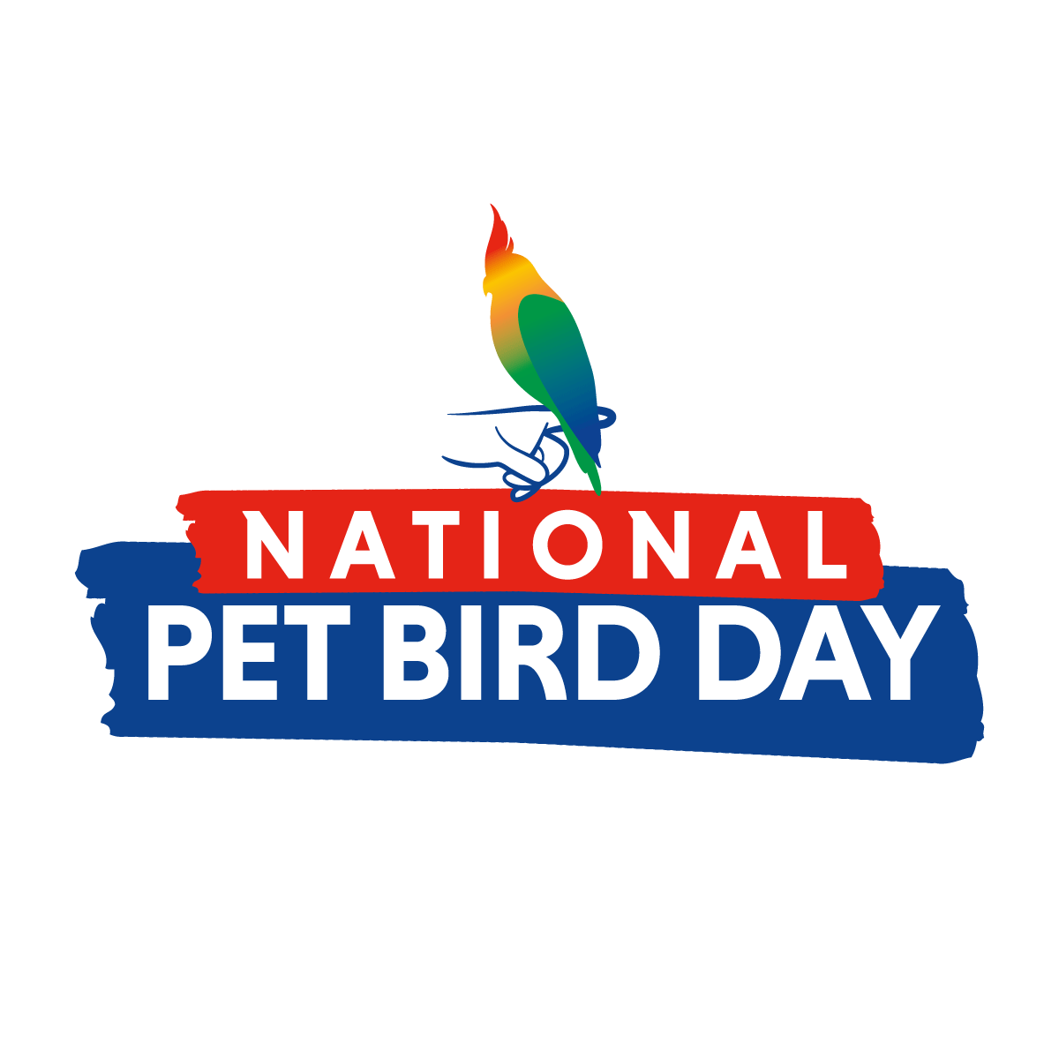

Celebrate National Pet Bird Day on September 17

The Bird Enjoyment & Advantage Koalition (BEAK) created National Pet Bird Day as a way to celebrate the joys and benefits of pet bird ownership.

Attention, pet bird owners and lovers—be sure to mark your calendars for September 17, 2024, which will be the 6th Annual National Pet Bird Day! This special day of celebration was created in 2019 to recognize all of the wonderful ways in which pet birds enrich our lives, as well as to educate current and potential bird owners about the responsibilities and commitments that come with having a companion bird.

Some of the main goals of National Pet Bird Day include:

- Recognizing and celebrating the important role of pet birds in our lives
- Uniting pet bird owners who all share a commonality of loving birds
- Providing education on the responsible care of companion birds
- Raising awareness on the joys and benefits of adding a bird to your home

The Joys of Owning a Pet Bird

What is it exactly that bird owners love most about their feathered companions? Commonly cited perks include the fact that birds are fun to watch and have in the household, as well as the love, companionship, affection, and stress relief they provide. In addition, studies indicate that birds can increase social interaction—which is essential for mental health and wellbeing—and pets of various types can be instrumental in teaching children empathy and responsibility.

Here are a few fun bird facts according to data from the American Pet Products Association’s (APPA) 2023-24 National Pet Owners Survey:

- An estimated 6.1 million U.S. households now include pet birds, representing a 7% increase over the last five years.
- Millennials are the top bird-owning demographic, with 43% of current bird owners belonging to the Millennial generation. Nineteen percent are members of Gen Z.
- Bird owners have an average of 2.14 birds each.
- Parakeets are the most popular type of pet bird—23% of bird owners have parakeets!
- 55% of bird owners say the top benefit of their pet is that they are fun to watch and have in the household, while 46% of owners say companionship is the biggest benefit.
- 93% of bird owners say they purchase treats for their birds and 77% buy gifts, spending an average of $50 per gift.

Celebrating National Pet Bird Day

Want to join in the fun this National Pet Bird Day and celebrate the many benefits of having a companion bird? There are many ways to participate! Here are a few ideas:

- Post celebratory bird photos, stories, stats and articles on social media and use the hashtag #NationalPetBirdDay
  - Visit https://myrightbird.com/national-pet-bird-day for downloadable memes and post copy
  - Tag @MyBird on Facebook and @MyRightBird on Instagram
- Participate in our “My Beautiful Pet Bird” contest! Simply submit a photo or short video showcasing what makes your feathered friend so special for a chance to win prizes up to $500! Visit the My Beautiful Pet Bird contest page for contest rules and details!
- Take our pet bird matchmaker quiz at www.MyRightBird.com to see types of birds that may be right for your lifestyle, and then share your results online!
- Show your pet bird how much you love them by getting them a new toy or treat and giving them a little extra love on September 17
- Subscribe to our email list for the latest pet bird tips, news, and special offers. Many of our pet bird retailers and product manufacturers run special promotions in honor of National Pet Bird Day, so now is the time to subscribe if you haven’t already!
- Follow @MyBird on Facebook and @MyRightBird on Instagram, and share your stories and photos with us using the hashtag #NationalPetBirdDay

No matter how you choose to participate, we hope you’ll join us in celebrating National Pet Bird Day and taking the opportunity to share the many benefits our winged friends bring to our lives. Visit www.MyRightBird.com for more information.

If you are a business in the pet bird industry and would like to learn more about joining BEAK/MyBird, we encourage you to get in touch with us at info@myrightbird.com!

