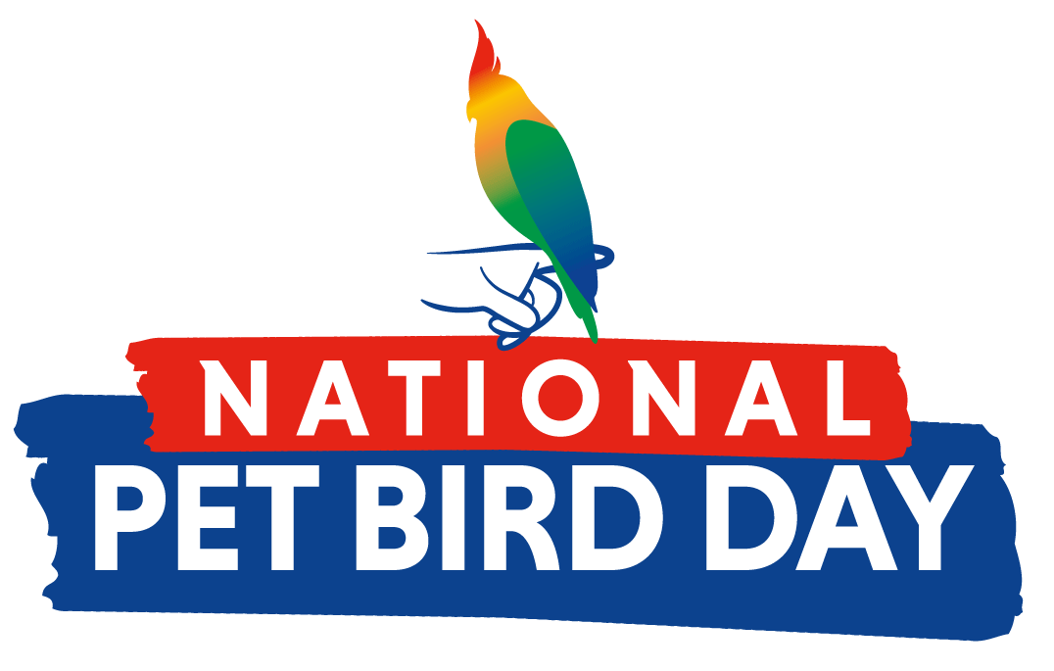

FOR IMMEDIATE RELEASE

August 15, 2021

Media Contact: Jamie Baxter

The Impetus Agency
jamie@theimpetusagency.com
775-322-4022

Celebrate National Pet Bird Day on September 17
Founded by the Bird Enjoyment & Advantage Koalition (BEAK), National Pet Bird Day celebrates the joys and benefits of bird ownership

(Washington, DC)– The Bird Enjoyment & Advantage Koalition (BEAK), a concentrated effort to educate on and grow responsible bird ownership, is excited to announce the 3rd annual National Pet Bird Day, which will take place Friday, September 17, 2021. Pet bird owners are encouraged to share stories, photos and videos of their birds using the hashtag #NationalPetBirdDay, while others can learn more about the joys and benefits of bird ownership.

“Birds are amazing companion animals and are actually very connected to their owners,” said Brent Weinmann, BEAK Chairman. “National Pet Bird Day serves as a day to celebrate all the amazing ways pet birds enrich our lives, educate on responsible bird ownership and encourage others to consider adding a feathered family member to their flock.”

What is it exactly that bird owners love most about their beloved companions? According to the American Pet Products Association, bird owners say the top benefits are that birds are fun to watch/have in the household, they provide love, companionship, company and affection, and even relieve stress. But there’s more, studies show birds can also increase social interaction, which is very important to mental health and wellbeing, and pets can be instrumental in teaching children empathy and responsibility. Currently, Millennials represent the largest demographic of bird owners with 45 percent of bird owners being Millennial.

For those interested in adding a bird to their home, BEAK offers an interactive quiz at www.myrightbird.com where a series of questions help match users with the right bird for their lifestyle. Quiz questions range from time and financial commitments, living arrangements and noise tolerance, to birds’ level of affection and expected lifespan; all key factors for potential bird owners to consider.

“We understand that birds like any pet can be a big commitment and through our resources like the quiz, bird locator, species information and avian vet locator we hope to provide new bird owners the information they need to enjoy the happiness and beauty they bring to a home,” said BEAK president, Dean Reyes.

Follow @MyRightBird on social media leading up to National Pet Bird Day for live educational demonstrations, giveaways, photo contests and more! To learn more about National Pet Bird Day visit www.nationalpetbirdday.com for a downloadable toolkit and other ways to participate.

###

About BEAK
Founded in 2016, the Bird Enjoyment and Advantage Koalition (BEAK) consists of bird product manufacturers, associations and caregivers with shared interests to address the need for increased, responsible bird ownership. BEAK’s mission is to conduct research, identify existing resources, opportunities and challenges, and educate and drive awareness of the benefits of bird ownership through strategic communications, marketing, collaborations and initiatives. www.MyRightBird.com

